Thornhill Secondary School

**TEJ3M1 Final Summative Assignment**

Remote control car

Justin Cai & Henry Xue

TEJ3M1 - 02

MR.Benum

January 23rd, 2017

member: **Justin and Henry**

Brief Idea:

We are going to create a moving car with ability to turn, light up in the dark(light sensor), automatically decrease maximum velocity when it sense object in front of it(if possible using the infrared sensor), We would control the car using a bluetooth chip(most likely) or wire(less likely).

What do we need:

* car base(wheels and base)
* Wireboard
* Arduino integrated circuit
* Wires
* Bluetooth chip(HC-06)
* Resistors
* Battery
* Transistors
* LED light
* Light depends resistor
* infrared sensor.
* Integrated logic gate(possible)
* Arduino app for bluetooth control.

Circuit:

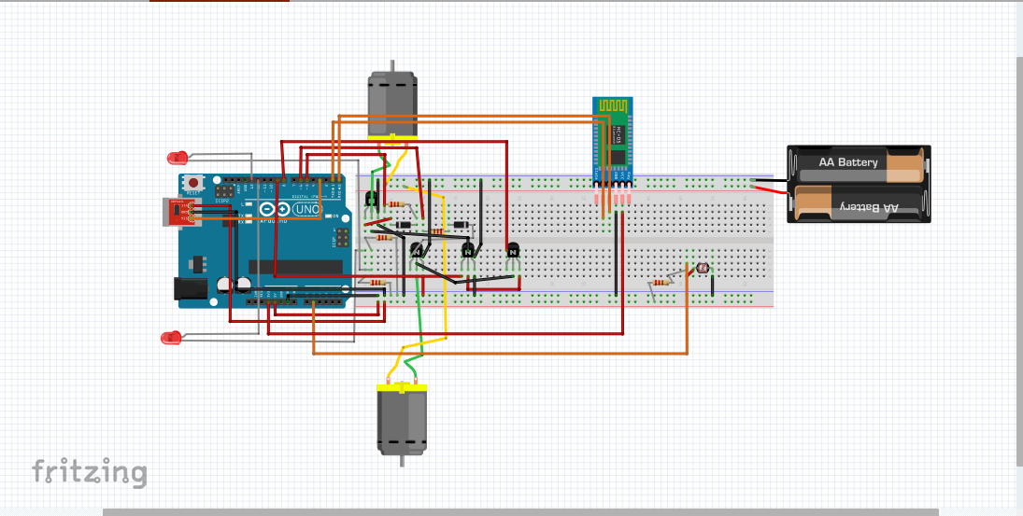How are the work being divided:

Justin: Wiring, planning, learning how to program from Henry because he is good at it, testing the final product

Heney: Programming and teach Justin, testing the final product.

Software requirement:

The program would take input of going forward, turning right, and turning left. The program would also allow the user to take input and activate the led front light. The program itself would activated the LED when the surrounding is dark. The program itself would warn the user if any object is in front of the car within 20cm. The program would not allow user to activate both motor at the same time if any object is in front of the car within 10 cm.

The input of the program is provided by HC-06 bluetooth chip.

User input: forward, right, left, lighton.

<http://www.instructables.com/answers/How-do-I-turn-the-wheels-of-a-toy-car/> e

